MKS System
# Source: AI Source: Provided by: [Data Path: Persons Table -> ID Column: 1, Name_En Column: Motasem Essam] -> From: [ChatGPT] on [7/17/2026]
The MKS System (Meter–Kilogram–Second System) is a metric measurement system that uses the meter (m) as the unit of length, the kilogram (kg) as the unit of mass, and the second (s) as the unit of time. It was developed to provide a practical and coherent system of measurement for science and engineering and later became the foundation of the International System of Units (SI).
The MKS system was widely adopted in physics, engineering, mechanics, and industrial applications because its units are well suited to measurements encountered in everyday life and scientific work.

Definition
# Source: AI Source: Provided by: [Data Path: Persons Table -> ID Column: 1, Name_En Column: Motasem Essam] -> From: [ChatGPT] on [7/17/2026]
The MKS System is a metric measurement system based on three fundamental units:
- Meter (m) for length
- Kilogram (kg) for mass
- Second (s) for time
Its name comes from the initials of these three base units:
$$\boxed{\text{MKS}=\text{Meter–Kilogram–Second}}$$

History
# Source: AI Source: Provided by: [Data Path: Persons Table -> ID Column: 1, Name_En Column: Motasem Essam] -> From: [ChatGPT] on [7/17/2026]
The MKS system evolved from the earlier CGS (Centimeter–Gram–Second) system to provide larger, more practical units for engineering and industrial applications.
Key milestones:
- Late 19th century – MKS units gained popularity in engineering.
- 1901 – Giovanni Giorgi proposed extending the MKS system by adding an electrical unit (the ampere), creating the MKSA System.
- 1960 – The MKSA system became the basis for the International System of Units (SI).

Characteristics
# Source: AI Source: Provided by: [Data Path: Persons Table -> ID Column: 1, Name_En Column: Motasem Essam] -> From: [ChatGPT] on [7/17/2026]
The MKS system is:
- Metric-based.
- Decimal-based.
- Coherent.
- Based on three fundamental units.
- Well suited for scientific and engineering calculations.
- The direct predecessor of the SI system.

Fundamental Units
# Source: AI Source: Provided by: [Data Path: Persons Table -> ID Column: 1, Name_En Column: Motasem Essam] -> From: [ChatGPT] on [7/17/2026]

Physical Quantity | MKS Unit | Symbol
Length | meter | m
Mass | kilogram | kg
Time | second | s

Base Units
# Source: AI Source: Provided by: [Data Path: Persons Table -> ID Column: 1, Name_En Column: Motasem Essam] -> From: [ChatGPT] on [7/17/2026]
1. Meter (m)
Measures:
- Length
- Distance
- Height
- Width
Example:
$$12\text{ m}$$

2. Kilogram (kg)
Measures:
- Mass
Example:
$$75\text{ kg}$$

3. Second (s)
Measures:
- Time
Example:
$$60\text{ s}$$

Derived Units
# Source: AI Source: Provided by: [Data Path: Persons Table -> ID Column: 1, Name_En Column: Motasem Essam] -> From: [ChatGPT] on [7/17/2026]
Many physical quantities are derived from the three base units.
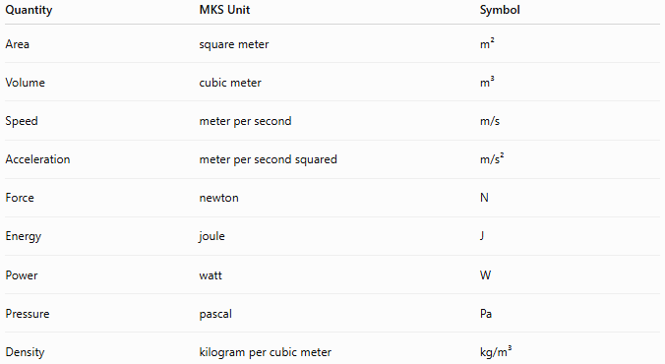
Quantity | MKS Unit | Symbol
Area | square meter | m²
Volume | cubic meter | m³
Speed | meter per second | m/s
Acceleration | meter per second squared | m/s²
Force | newton | N
Energy | joule | J
Power | watt | W
Pressure | pascal | Pa
Density | kilogram per cubic meter | kg/m³

Common Derived Units
# Source: AI Source: Provided by: [Data Path: Persons Table -> ID Column: 1, Name_En Column: Motasem Essam] -> From: [ChatGPT] on [7/17/2026]
Force
The MKS unit of force is the newton.
Definition:
A newton is the force required to accelerate a mass of 1 kilogram at 1 meter per second squared.
$$\boxed{1\text{ N}=1\text{ kg}⋅\text{m}/{\text{s}}^{2}}$$

Energy
The MKS unit of energy is the joule.
Definition:
A joule is the work done when a force of one newton moves an object one meter.
$$\boxed{1\text{ J}=1\text{ N}⋅\text{m}}$$

Power
The MKS unit of power is the watt.
Definition:
A watt is one joule of energy transferred per second.
$$\boxed{1\text{ W}=1\text{ J}/\text{s}}$$

Pressure
The MKS unit of pressure is the pascal.
Definition:
$$\boxed{1\text{ Pa}=1\text{ N}/{\text{m}}^{2}}$$

Examples
# Source: AI Source: Provided by: [Data Path: Persons Table -> ID Column: 1, Name_En Column: Motasem Essam] -> From: [ChatGPT] on [7/17/2026]
Example 1
Length
$$15\text{ m}$$

Example 2
Mass
$$2.5\text{ kg}$$

Example 3
Speed
$$20\text{ m/s}$$

Example 4
Force
$$50\text{ N}$$

Advantages
# Source: AI Source: Provided by: [Data Path: Persons Table -> ID Column: 1, Name_En Column: Motasem Essam] -> From: [ChatGPT] on [7/17/2026]
The MKS system:
- Uses practical-sized units.
- Is easy to convert using decimal multiples.
- Is well suited for engineering and physics.
- Forms the basis of the SI system.
- Provides coherent derived units.

Disadvantages
# Source: AI Source: Provided by: [Data Path: Persons Table -> ID Column: 1, Name_En Column: Motasem Essam] -> From: [ChatGPT] on [7/17/2026]
The MKS system:
- Has largely been replaced by the more comprehensive SI system.
- Does not include additional base units (such as electric current or temperature) that are part of SI.

Applications
# Source: AI Source: Provided by: [Data Path: Persons Table -> ID Column: 1, Name_En Column: Motasem Essam] -> From: [ChatGPT] on [7/17/2026]
The MKS system has been used in:
- Mechanics
- Physics
- Engineering
- Construction
- Manufacturing
- Industrial design
- Scientific research
Today, its units remain in use because they are incorporated into the SI system.

Everyday Examples
# Source: AI Source: Provided by: [Data Path: Persons Table -> ID Column: 1, Name_En Column: Motasem Essam] -> From: [ChatGPT] on [7/17/2026]
MKS units are used when:
- Measuring room dimensions in meters.
- Recording body mass in kilograms.
- Timing events in seconds.
- Measuring vehicle speed in meters per second (scientific contexts).
- Calculating force in newtons.

Common Mistakes
# Source: AI Source: Provided by: [Data Path: Persons Table -> ID Column: 1, Name_En Column: Motasem Essam] -> From: [ChatGPT] on [7/17/2026]
- Confusing the MKS system with the SI system (the MKS system is the foundation of SI but does not include all SI base units).
- Mixing MKS units with CGS units.
- Confusing kilograms (mass) with newtons (force).
- Omitting unit symbols in calculations.

Key Points
# Source: AI Source: Provided by: [Data Path: Persons Table -> ID Column: 1, Name_En Column: Motasem Essam] -> From: [ChatGPT] on [7/17/2026]
- MKS stands for Meter–Kilogram–Second.
- It is a metric, decimal-based measurement system.
- Its base units are the meter, kilogram, and second.
- Important derived units include the newton, joule, watt, and pascal.
- The MKS system became the foundation of the International System of Units (SI).

MKS System vs. SI System
# Source: AI Source: Provided by: [Data Path: Persons Table -> ID Column: 1, Name_En Column: Motasem Essam] -> From: [ChatGPT] on [7/17/2026]
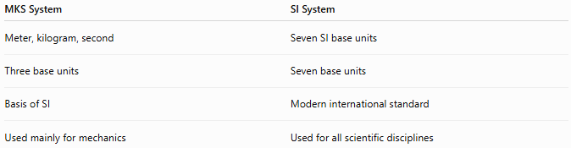
MKS System | SI System
Meter, kilogram, second | Seven SI base units
Three base units | Seven base units
Basis of SI | Modern international standard
Used mainly for mechanics | Used for all scientific disciplines

MKS System vs. CGS System
# Source: AI Source: Provided by: [Data Path: Persons Table -> ID Column: 1, Name_En Column: Motasem Essam] -> From: [ChatGPT] on [7/17/2026]
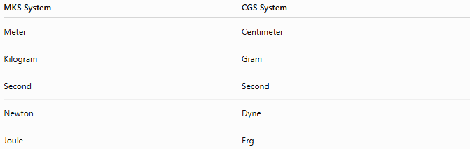
MKS System | CGS System
Meter | Centimeter
Kilogram | Gram
Second | Second
Newton | Dyne
Joule | Erg

MKS System vs. Imperial System
# Source: AI Source: Provided by: [Data Path: Persons Table -> ID Column: 1, Name_En Column: Motasem Essam] -> From: [ChatGPT] on [7/17/2026]
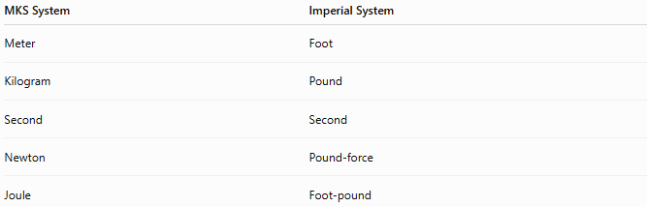
MKS System | Imperial System
Meter | Foot
Kilogram | Pound
Second | Second
Newton | Pound-force
Joule | Foot-pound

Conclusion
# Source: AI Source: Provided by: [Data Path: Persons Table -> ID Column: 1, Name_En Column: Motasem Essam] -> From: [ChatGPT] on [7/17/2026]
The MKS (Meter–Kilogram–Second) System is a metric measurement system based on the meter, kilogram, and second as its fundamental units. It provided a practical and coherent framework for scientific and engineering measurements and introduced widely used derived units such as the newton, joule, watt, and pascal. The MKS system later evolved into the International System of Units (SI), making it one of the most important milestones in the history of standardized measurement.

